**GENERAL GUIDELINES OF HALAL SCHEME SYSTEM**

| **Date** | **Release/Amendment summary** | **Revision** | **Pages affected** | **Author** | **Approval** |
| --- | --- | --- | --- | --- | --- |
| 17th October 2024 | First draft | First draft | - | -- | – |
|  |  |  |  |  |  |
|  |  |  |  |  |  |
|  |  |  |  |  |  |
|  |  |  |  |  |  |

**Content**

Preface

Content

List of Figure

List of Table

List of appendix

1. Introduction
   1. Background
   2. Objective
2. Definition and terminology
   1. Definition
   2. Terminology in Halal Certification Process
3. Halal Certification
   1. Halal Certification Process
   2. Application
   3. Indicative budget
   4. Closed budget
   5. Application review
   6. Audit stage 1
   7. Audit stage 2
   8. Request documentation
   9. They meet the requirements
   10. Certification Committee meeting
   11. Contract agreement
   12. Grant certificate
   13. Suspension, withdrawal & reduction of scope
   14. Surveillance audit
   15. Renewal audits
4. Principles of HS
5. Manual of Halal Scheme (HS)

5.1. Halal Scheme System

1. Halal Policy
2. Halal Guidelines
3. Halal Management Organization
4. Standard Operating Procedures (SOPs)
5. Technical References
6. Administration System
7. Documentation System
8. Socialization Program
9. Training Program
10. Internal and External Communication System
11. Internal Audit System
12. Corrective Action System
13. Management Review System
14. Halal Scheme (HS) Implementation Assessment

7.1. Principles and Procedure of HS Assessment

7.2. Assessment of HS Manual (on desk appraisal of HS)

7.3. Assessment of HS Implementation

7.4. Grant

VIII. HS Implementation Advantages

**List of Appendix**

1. Example of Halal Policy
2. Halal Guidelines
3. Decision Tree for Haram Critical Points Identification
4. Example of List of Identified Haram Critical Materials and
5. Its Preventive Actions
6. Example of List of Identified Haram Critical Production Process
7. and Its Preventive Actions
8. Example of Halal Standard Operating Procedure (SOP)
9. Example of Administration System
10. Example of Documentation System
11. Example of Training Schedule
12. Form of Periodic Report
13. Example of Form for Internal Audit
14. Example of Format Report on Non-Conformity
15. Example of Minutes of Management Meeting on HS Review
16. **Introduction**

**References**

| 1. ISO/IEC 17021-1:2015 | Management systems audit guide |
| --- | --- |
| 2. ISO/IEC 17065 | Conformity assessment — Requirements  for bodies certifying products, processes  and services |
| 3. UAE.S/ GSO 2055- 1:2015 | Halal food - Part 1: General Requirements |
| 4. GSO 2055-2:2015 | Halal Products – Part 2: General Requirements for Halal Certification Bodies |
| 5. UAE.S 2055-2:2021 | Halal Products – Part Two: General Requirements for Halal Certification Bodies |
| 6. GSO 993/2015 | Animal Slaughtering Requirements According to Islamic Rules |
| 7. MS 1500:2019 | Halal food – production, preparation, handling, and storage – general guidelines (third revision) |
| 8. Malaysian Protocol | For Halal meat and poultry production |
| 9. ISO 19011:2018 | Management systems audit guide |
| 10. BPJPH SJPH (Indonesia National Halal Product Assurance Standard/Regulation) | Quality Management System Guide |
| 11. ISO 22000 | Food Safety Management Guide |
| 12. OIC/SMIIC 1:2019 Standards | General Requirements for Halal Food |
| 13. GSO 1694 | General Principles of Food Hygiene |
| 14. GSO 2055-4: 2021 | Requirements for Halal Cosmetics and Personal Care |
| 15. AHF Halal Standards | AHF Standards for Halal Product(s) |

* 1. **Background**

Every producer must fulfill the needs and rights of consumers, including Muslim

consumers. Producing halal products is part of company responsibility to Muslim

consumers. To assure consumers that the products are halal, company needs to have

AHF’s certificate.

Validity of AHF certificate is with a 3 (three) years cycle. Along that period,

company must assure Muslim consumers that they will consistently maintain the halalness

of their products. Therefore, some accreditations require company to set up a system

namely Halal scheme. This scheme is arranged by company according to its conditions.

* 1. **Objective**

AHF operates the following Certification Schemes covering its Halal certification

Activities.

1. Processing of perishable animal products
2. Processing of perishable plant products
3. Processing of perishable animal and plant
4. Processing of ambient stable products
5. Animal slaughtering Processing of carcasses including slaughtering in slaughterhouses, cutting, cleaning and packing.

The objective of Halal Scheme implementation is to maintain sustainability of halal production

process to assure its halalness according to the Islamic rules and the international

standards.

1. **Definition and Terminology**

**2.1. Definition**

Halal scheme System is an arranged, applied and maintained system by halal

certified company to maintain sustainability of halal production process.

**2.2 Terminology in Halal Certification Process**

**1. Halal Certification**

Halal Certificate confirms that the product, the service, or the regulations specified meets

Halal requirements in the Islamic Sharia such as Halal Tazkeya certificates, facilities, and

Farms certificates, slaughterhouses certificates, facilities classified as Halal, primary

products components, additives containing meat/poultry and their derivatives, rennet,

gelatin, animal fats and oils and their derivatives.

**2. Auditing**

Auditing is an independent, systematic, and functional observation to determine

the conformity of an activity and its output with the objectives planned.

**3. Auditor of AHF**

Auditor is a person assigned by AHF through a selection process

including his/her competency, quality and integrity to conduct halal audit. Auditor

is a representative of sharia and a witness to find facts on halal production of a

company.

**4. HS**

Halal Scheme system implementation.

**5. Audit Evaluation**

Audit evaluation is an evaluation of audit result through mechanism of auditor

meeting.

**6. Internal Halal Auditor**

Internal Halal Auditor is staff(s) officially appointed by Company Management to

coordinate implementation of HS.

**7. Fatwa**

Fatwa is Islamic legal opinion about the law status of a certain case. In halal

certification process, fatwa output is the halal or haram status of product(s)

based on the auditing process performed by AHF.

**8. Islamic rules**

It means what ALLAH legislates for Muslims as per the Holy Qur’an, and the practices

(Sunnah) of the honorable Prophet Mohammed (peace be upon him).

**9. Certification Committee**

Certification Committee is one of AHF committees whose task to produce an

Islamic legal opinion about law status and conformity. Members of certification

committee are representatives who make the decision on granting certification.

**10. Company status on HS implementation:**

a. Applicant: company which has not yet obtained AHF certificate.

b. Client: company which has already obtained halal certificate.

c. Renewal: company which has already obtained halal certificate and conformed to

HS implementation.

1. **Halal certification** 
   1. **Halal Certification Process**

Flow chart of Halal Certification Procedure in figure 1.

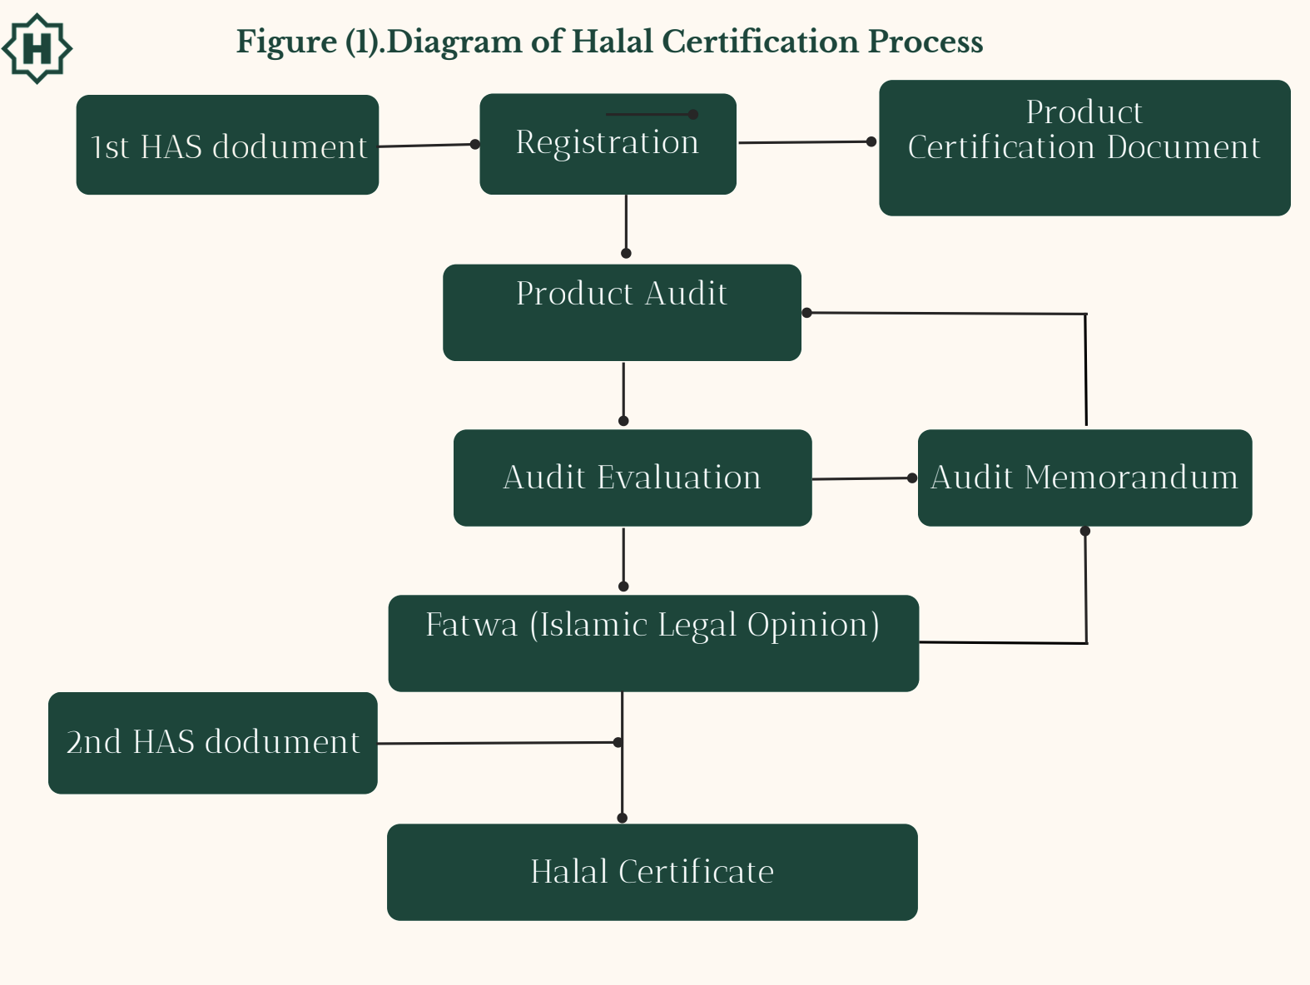

**3.2 Application:**

AHF requires the applicant for the Halal certificate to provide detailed information concerning its legal status/entity, raw materials, operations, product safety management system related issues i.e. HACCP studies, the number of shifts and number of employees in each shift, etc.

The process is initiated when an applicant makes an inquiry, or an order is received through sales activities. The applicant is informed of the basic certification process. The application form for the preparation of a financial proposal is sent to the applicant so that an application can be prepared and completed. Once receiving the filled application form, the admin team will send the filled application form to the quality and control department without making any changes. The quality department will calculate the man-days based on given information by the client in the application and send to the admin department. Applicants should submit a list of management documents and all products produced by the company.

**3.3 Indicative budget:**

* + 1. AHF sends an indicative budget

* 1. **Closed Budget:**

3.4.1 Agreement of fees and charges of the halal certification.

* 1. **Application review:**

Before proceeding with the audit, AHF conducts a review of the application and supplementary information for certification to ensure that:

1. The information about the Client and its production is sufficient for the conduct of the audit.
2. The requirements for certification are clearly defined and documented and have been provided to the Client.
3. any known difference in understanding between AHF and the Client is resolved.
4. AHF has the competence and ability to perform the Certification activity.
5. the scope of certification sought, the location(s) of the Client’s operations, time required to complete audits and any other points influencing the Certification activity are taken into account (language, safety conditions, threats to impartiality, etc.).
6. records of the justification for the decision to undertake the audit are maintained.

After reviewing the Application, AHF decides whether to accept the Application or not. If the AHF does not accept the application for certification due to the lack of necessary resources and/or competence of the Certification Body or non-compliance of the Client’s production with the requirements on Halal production, AHF informs the Client about this and explains the reasons for the refusal (in all cases the Application review fee is non-refundable). AHF does not provide any advice on the achievement of compliance of the Client’s products with the Halal standards. If the documents are found complete in all aspects, the application is ready for further submission at the next stage for scrutiny and audit approved by the general manager and the certification director.

* 1. **Audit stage 1:** 
     1. Perform On-site audit stage 1.

The objectives of stage 1 audit is to provide an illustration for planning stage 2 audit by gaining an understanding of the product safety management system in the context of the Client’s food safety hazard identification, analysis, HACCP plan and PRPs, policy and objectives, and, in particular, the Client’s state of preparedness.

Stage 1 audit can be carried out at the premises of AHF or at the applicant’s organization premises according to complexity of production or service in order to achieve the desired objectives of an audit.

a. In the case of categories A, B, G, H, I, J and K, it is not necessary for stage 1 audit to be on-site. However, it is the discretion of the AHFs audit team to decide to carry out an on-site audit. In categories C, D, E, F, L, M and N, it is obligatory that stage 1 audit is done on-site.

b. Where stage 1 audit has not been performed on-site, the duration of stage1 audit may not exceed 20% of the total audit time. Where it covers on-site work, duration of the stage 1 audit may not exceed 30% of the total audit duration.

AHF performed the Stage 1 audit to

a. audit the client's management system documentation

b. evaluate the client's location and site-specific conditions and to undertake discussions with the client's personnel to determine the preparedness for the stage 2 audit.

c. Review the client's status and understanding regarding requirements of the standard, in particular with respect to the identification of key performance or significant aspects, processes, objectives and operation of the management system.

d. Collect necessary information regarding the scope of the management system, processes and location(s) of the client, and related statutory and regulatory aspects and compliance (e.g. quality, environmental, legal aspects of the client's operation, associated risks, etc.).

e. Review the allocation of resources for stage 2 audit and agree with the client on the details of the stage 2 audit.

f. Provide a focus for planning the stage 2 audit by gaining a sufficient understanding of the client's management system and site operations in the context of possible significant aspects.

g. Evaluate if the internal audits and management review are being planned and performed, and that the level of implementation of the management system substantiates that the client is ready for the stage 2 audit.

When part of the production process is outsourced, stage 1 audit reviews the documentation included in Halal requirements and/or the product safety management system to determine if the combination of control measures is suitable for the Client and conform to requirements of Halal standards.

AHF shall document Stage 1 audit findings and communicate to the client, including identification of any areas of concern that could be classified as nonconformity during the stage 2 audit. AHF also informs the results of stage 1 audit to the applicant which may lead to postponement or cancellation of stage 2 audit.

Any part of the product safety management system that is audited during stage 1 audit and determined to be fully implemented, effective and in conformity with requirements, may not need to be re-audited during stage 2 audit. However, the AHF ensures that the already audited parts of the product safety management system continue to conform to the certification requirements. In this case, AHF shall include these findings in stage 2 audit report and shall clearly state that conformity has been established during stage 1 audit.

A detailed report on the first phase of the audit showing the audit results (consistent with the client's production objectives for the first phase of the audit) as well as potential areas of concern that can be identified as inconsistencies during the second phase of the audit is granted to the Client and after that the date of the second stage of the audit is agreed with the Client. If there are serious inconsistencies during the first stage of the audit, the Client is given some time to correct these inconsistencies.

The interval between the first and second stages of the audit is established considering the interests of the Client and giving them time to correct potential non-conformances but cannot exceed 6 (six) months. If non-conformances are not eliminated and/or this elimination is not accepted by AHF within this period, the Stage 2 audit is canceled.

* 1. **Audit stage 2:**

The purpose of the second stage of the audit is to check the effectiveness of implementation of the requirements of the production of Halal products by the Client and verification of compliance with the stated standards. The second stage is always carried out in the client’s production facility and includes the following:

a. Collection of information and evidence of compliance of production with Sharia Law and the requirements of the declared standards.

b. Monitoring, measuring, reporting and reviewing compliance with the basic requirements and objectives of the stated standard.

c. Verification of the production ability to comply with regulatory and legal requirements and the requirements specified in the Halal Certification Agreement.

d. Internal auditing and management review.

e. Management responsibility for the client's policies

f. Links between the normative requirements, policy, performance objectives and targets (consistent with the expectations in the applicable certification standard or other normative document), any applicable legal requirements, responsibilities, competence of personnel, operations, procedures, performance data and internal audit findings and conclusions

g. Verification of Halal production control products.

h. Checking of the non-conformances/faults management system.

The audit team analyzes the results and evidence gathered during both phases of the certification audit to review the audit findings, agree on the audit conclusions and draw up an audit report. AHF has assigned the responsibility to the Quality manager to review all information and results related to the evaluation and submit to the certification department for further proceedings. The delay of the stage1 and stage 2 should not exceed 6 months.

3.7.1 Perform on-site audit stage 2 evaluation, take samples, and perform tests.

3.7.2 In case of critical non-conformity, perform another audit.

3.7.3 Close nonconformities recommend grant of certificate

* 1. **Request documentation:**
     1. Fact sheets and Licences.
  2. **They meet the requirements:** 
     1. Closing of the corrections, corrective actions, and complaints and appeals reviewed by the quality manager.
  3. **Certification committee meeting:** 
     1. Decision to grant or deny the halal certificate after review of the closing of corrective actions by the certification committee and final sign of the committee.

AHF Halal Certification Committee is responsible for all decisions on granting, refusing, suspending, withdrawing, and expanding/reducing Halal Certification and its scope. The procedure includes the assessment of the sufficiency of information provided by the audit team, assessment of the content of all audit reports and Application documents, critical evaluation of all risks and information received from the Halal Certification Unit and the Shariah Committee. The information provided to the certification decision committee includes, as a minimum the audit reports, comments on the nonconformities, the correction and corrective actions taken by the client, confirmation of the information provided to the certification body used in the application review, and a recommendation whether or not to grant certification, together with any conditions or observations. AHF ensures that personnel granting halal certificates fulfill all the competency requirements. The team taking the certification decision is not less than 3, including an Islamic affairs expert and the decisions are taken unanimously, not by majority of votes. The procedure for making the decision is as follows.

1. Halal Certification Committee analyzes all the information, reports and feedback provided by the Halal Certification Unit. It critically reviews this information in terms of a client’s production compliance with Halal production and certification standards, requirements and regulations by applying the critical analysis technique and knowledge of these standards, requirements and regulations. After the review of all provided information, the voting takes place.

2. After the vote the decision on granting/refusing Halal Certificate is protocolled and the official conclusion including the decision and the reason for this decision is provided to the Halal Certification Unit. Decisions are taken unanimously, not by majority of votes.

3. If the decision is negative, the Halal Certification Unit informs the Client about the decision and reason for it. In this case the Halal Certification process ends at this point.

4. If the decision is positive, the certification department will prepare Halal certificate with all the relevant information related to the product.

5. Upon completion of the certificate the same is given to the President for the approval.

6. Upon completion of the above, AHF will issue a Halal certificate with a validity period of 03 years, starting as of the date on which certification is granted. Halal certificate is issued to the client after approval of the President. The time to issue a Certificate is a maximum of 30 working days.

7. The Certificate specifies the name and address of the certification body, the date of granting certification, the name and address of the client, the scope of certification, the expiry date of certification, the signature or other defined authorization of the person(s) of the AHFB assigned such responsibility.

8. The AHF Halal Logo is issued at this stage for use.

* 1. **Agreements:**
     1. Signing of the contract agreement by AHF Vice President and applicant.
  2. **Grant of the certificate: (3 years cycle)**

3.12.1 Define the scope of halal certification in terms of halal product /service categories,

grant certificate after confirming the definite result by the certification director.

* 1. **Suspension, withdrawal & reduction of scope:**

3.13.1 All rights reserved to suspend, withdraw, or reduce the scope of halal certification at any time if there is any breach of the conditions or guidelines found in Halal certified products, a change of ownership, the fee or any part thereof remains unpaid or at the expiry of the halal certificate.

* 1. **Surveillance audits:**

- AHF will conduct surveillance audits for first and second years following the certification decision, in order to ensure continued compliance of Halal product/service with the requirements of the Halal certification, giving due regard to the requirements of the Halal product/service standard to which the Halal certification has been conducted and taking account of the nature of Halal product/service , requirements of the Halal certification, any nonconformities detected in the Halal product/service or Halal production/service premises or any complaints received with regard to certified Halal product/service.

- The intent is to ensure that any changes to the scope of the Halal certification audit are captured and monitored regularly to determine if the Halal certification is still representative of the actual management system. Surveillance audits will be conducted at the client site.

- Surveillance audits shall be conducted at least once a year. The date of the first surveillance audit following initial certification shall not be more than 12 months from the last day of the stage 2 audit. The deadline is calculated from the last day of the Stage 2 audit in each case. A Lead Auditor must participate in surveillance audits. The sector competence must be present in the audit team.

- During preparation of the audit, the audit team leader initiates an inquiry to the customer regarding changes in the structural and procedural organization, the size of the company and the company activities. This includes in particular a review of the current system documentation. In addition, materials used for public relations (e.g., Internet, advertising material) can be used for preparation purposes.

- Regular surveillance audits are carried out on the same principle as certification audits, but the audit program can be much shorter, depending on the complexity of the audited production, the results of previous audits and the established frequency of periodic audits. Surveillance audits are on-site audits, but are not necessarily full system audits, and are planned together with the other surveillance activities so that AHF can maintain confidence that the certified production continues to fulfil requirements between recertification audits. The surveillance audit programme shall include, at least:

* Internal audits and management review
* A review of actions taken on nonconformities identified during the previous audit.
* Treatment of complaints
* Effectiveness of the management system with regard to achieving the certified client's objectives,
* Progress of planned activities aimed at continual improvement.
* Continuing operational control;
* Review of any changes
* The use of Halal Mark and/or any other reference to certification.

- AHF also regularly reviews the documentation provided by the Client, and upon the expiration of the certificates provided, requests the new ones. The Client is given a certain amount of time to provide the updated certificates. If the renewed certificates are not provided at the set time, the validity of the Halal Certificate issued is suspended or revoked.

- In all cases, the procedures with regard to reports issued as a result of surveillance shall be determined by the Halal Certification Committee.

- Surveillance activities shall include on-site audits assessing the certified client's management system's fulfillment of specified requirements with respect to the standard to which the certification is granted.

Other surveillance activities may include

a) enquiries from the AHF to the certified client on aspects of certification,

b) reviewing any client's statements with respect to its operations (e.g. promotional material, website),

c) requests to the client to provide documents and records (on paper or electronic media), and d) other means of monitoring the certified client's performance.

- When continuing use of a certification mark is authorized for placement on a product (or its packaging, or information accompanying it) of a type which has been certified, surveillance shall be established by AHF and shall include periodic surveillance of marked products to ensure ongoing validity of the demonstration of fulfillment of product requirements.

- When continuing use of a certification mark is authorized for a process or service, surveillance shall be established and shall include periodic surveillance activities to ensure ongoing validity of the demonstration of fulfillment of process or service requirements.

-In case of nonconformities, the audit team leader should proceed as in the certification audit. Suspensions of the certificate must also be considered. When Halal production premises are audited and if non-conformances that directly affect Halal product safety are detected samples may be taken for the surveillance purposes. The audit file is then reviewed by the appointed decision committee after closure of all NCs.

- Decisions on continuing with existing Halal certification (certificate maintenance) will be made based on sufficient evidence that the client organization has continued to satisfy requirements of the management system standard(s).

- Decision for the date of the surveillance audit will be based on the date of certificate release by AHF during the previous audit cycle.

* Surveillance Preparations: starts 6 months after the date of certification.
* Surveillance audit: 9 months after the date of certification ± 3 months.
  1. **Renewal audits:**

AHF conducts Recertification Audits as a gauge of continued fulfillment of audit requirements and scope relevance for the Halal certificate owners (certified organization) once they submit a recertification application six (6) months prior to the expiry date of current Halal certificate.

- The recertification audit will only be conducted upon client extension of the contract for audit services. In case of contract termination, no recertification audits will occur to continue the client organization’s certification in the next cycle.

-The recertification audit will consider the results of prior audits and ensure that the client organization can demonstrate continued effectiveness of its management system against standards.

- The intent is to ensure that any changes to the scope of the certification audit are captured and monitored regularly to determine if the certification is still representative of the actual management system.

- In most cases, recertification audits are conducted in one stage. Recertification could be done in 2 stages if there are any major changes in the clients systems.

- The time interval for addressing non conformances in case of recertification audits varies depending on the clients’ certificate validity.

- Halal certificate owners who failed to renew their certificates will not be allowed to use the Halal mark at the premises or on the manufactured products. Gap-free recertification is also possible if the certification decision has been made 3 months at the most before the expiration date. Competence requirements for the auditors in a recertification audit will remain the same as for the initial audit. The auditor asks the company about any changes in the structural and procedural organization of the company, the size of the company, the company activities and the scope. In determining the calculation of the audit effort / audit program he shall take into account the results of previous audits and decide to waive the audit stage 1. It may be necessary to perform a Stage 1 audit in the context of a recertification audit if there have been significant changes to the management system or in relation to the activities of the company (e.g. changes in the law). The documentation shall be in the calculation/ audit program.

-Recertification audits include a review of management system documentation with confirmation of the review in the audit report. If there have been significant changes, the result of the review must be documented separately, and an onsite audit carried out. The results of the previous surveillance program(s) over the course of the certificate validity shall be considered. All requirements of the standard must be audited. The audit methodology is equivalent to the methodology of a Stage 2 audit.

Following points should also be reviewed in the recertification audit:

* effectiveness of the interaction between all quality management elements in the management system with regard to internal or external changes, and the continuing significance and applicability of the management system within the scope of the certification,
* verification that the obligation to maintain the effectiveness of the system and to improve it has been fulfilled in order to increase overall performance capacity within the organization,
* verification that the certified management system contributes to achievement of the policies and objectives of the organization.

Audit performance, documentation and also issue of certificates shall be performed in accordance with the rules applying to certification audits.

Normally the certification decision should be made before the expiration date of the certificate.

**3.16 Extension audit**

An extension audit can be performed to extend the scope of an existing certificate. The extension / reduction audit may be carried out within the scope of a surveillance audit, re-certification audit or on an independently selected date. The validity period of the certificate remains unaffected. Exceptions have to be justified in writing. The audit team leader / audit team will review the MS documents concerning the extended areas / new locations and audit all requirements which are affected by the extension.

The further procedure regarding the documentation and release of the audit procedure corresponds to a certification audit.

**3.17 Short-notice audits**

It may be necessary for the certification body to conduct audits of certified clients at short notice to investigate complaints, or in response to changes, or as follow up on suspended clients. In such cases

* the certification body shall describe the conditions under which these short notice visits are to be conducted,
* the certification body shall exercise additional care in the assignment of the audit team because of the lack of opportunity for the client to object to audit team members.

**3.18 Transfer of certificates from other Certification Bodies**

The following minimum requirements shall apply:

**Prerequisites**

As a rule, only certificates issued by accredited certification bodies can be transferred; the accrediting body must have signed the cooperation for Accreditations Multilateral Agreements (MLA). Companies with certificates from non-accredited certification bodies are to be treated as new customers.

**Pre-Transfer Review**

A Pre-Transfer Review must be conducted by a competent auditor always. This generally comprises review of important documents and a visit to the customer. Additional audit time might be necessary. The audit time depends on the size and complexity of the organization. If necessary, the additional audit time has to be documented in the calculation / Audit program. The Pre-Transfer Review must cover the following aspects:

* confirmation that the certified activities of the customer are covered by the scope of our own accreditation
* the reasons for transfer of the certificate
* confirmation that a valid management system certificate with regard to term of validity and performance profile of the customer, issued by an accredited certification body, is to be transferred;
* review of the previous reports on the certification or recertification audit and the subsequent surveillance audits and of all nonconformities dealt with in these reports: this discussion should also include all other available relevant documents and records on the certification process, such as hand-written notes and checklists.
* any complaints received and the action taken.
* the stage of the current certification cycle.

If the transfer is performed within the framework of a surveillance / recertification audit, the pre-transfer review can be performed in connection with the audit.

Performing the transfer audit in connection with the recertification audit, the form of the assessment of the certification period is substituted by the checklist / documentation on certificate transfer.

1. **Principles of HS:**
2. **Responsibility**

As its responsibility to Muslim community, AHF introduced HS as part

of halal certification process to guard the implementation of Islamic sharia

(Islamic law) which has basic aim to take care of the holiness of religion, mind,

soul, family, and properties of human beings, in halal matter.

1. **Honesty**

Companies must honestly explain all materials which are used as well as the production process in HS and running daily operation of halal production based on what is stated in HS.

1. **Trustworthy**

AHF trusts the company to set HS based on the real internal conditions of the company.

1. **Systematic**

Halal Scheme System is documented properly and systematically to make AHF easily trace its implementation proofs in the company.

1. **Socialized**

Implementation of Halal scheme System is responsibility at all levels from top level of management to the employees, therefore HS must be well-socialized in the company.

1. **Key person involvement**

Company involves persons in the management line to keep the implementation of Halal scheme System.

1. **Management Commitment**

Implementation of HS in company will be more effective if it is fully supported by

top management. Management must mention in written statement their halal

commitment in the company's halal policy.

1. **Delegating authority**

Management delegates an authority of halal production process to the internal

halal auditor(s).

1. **Traceability**

Each implementation of halal production is always recorded and able to be

traced

**11. Specific**

The system must identify each material as specific entity according to supplier,

manufacturer, and country of origin. It means that one code for one specific

material.

1. **Manual of HS** 
   1. **Halal Scheme System**
2. **Halal Policy**

Declaration of halal policy is a beginning step and becomes fundamental of a company in setting up and implementing Halal scheme System (HS). Halal policy is a written statement of a company including consistency in using and providing material (raw, additive, and supporting materials), as well as consistency in halal production process. Example of halal policy is attached in Appendix 4.

1. **Halal Guidelines**

Halal Guidelines is a guidance to identify haram critical points of material used and production process implemented by the company. It consists of:

* 1. Definition of Halal and Haram
  2. Al Qur’an and Fatwa reference
  3. Decision tree for haram critical points identification
  4. List of Identified Haram Critical Control Points of Materials and Its Preventive Actions
  5. List of Identified Haram Critical Control Points of Production Process and Its Preventive Actions
  6. Publication on website (<https://halalfoundation.org/>)

1. **Halal Management Organization**

Halal Management Organization is an internal organization in the company which manages whole management functions and activities in producing halal products. In organizing those functions and activities, companies should involve all related departments/divisions in halal production system. An example of Halal Management Organization is shown in Figure 3.

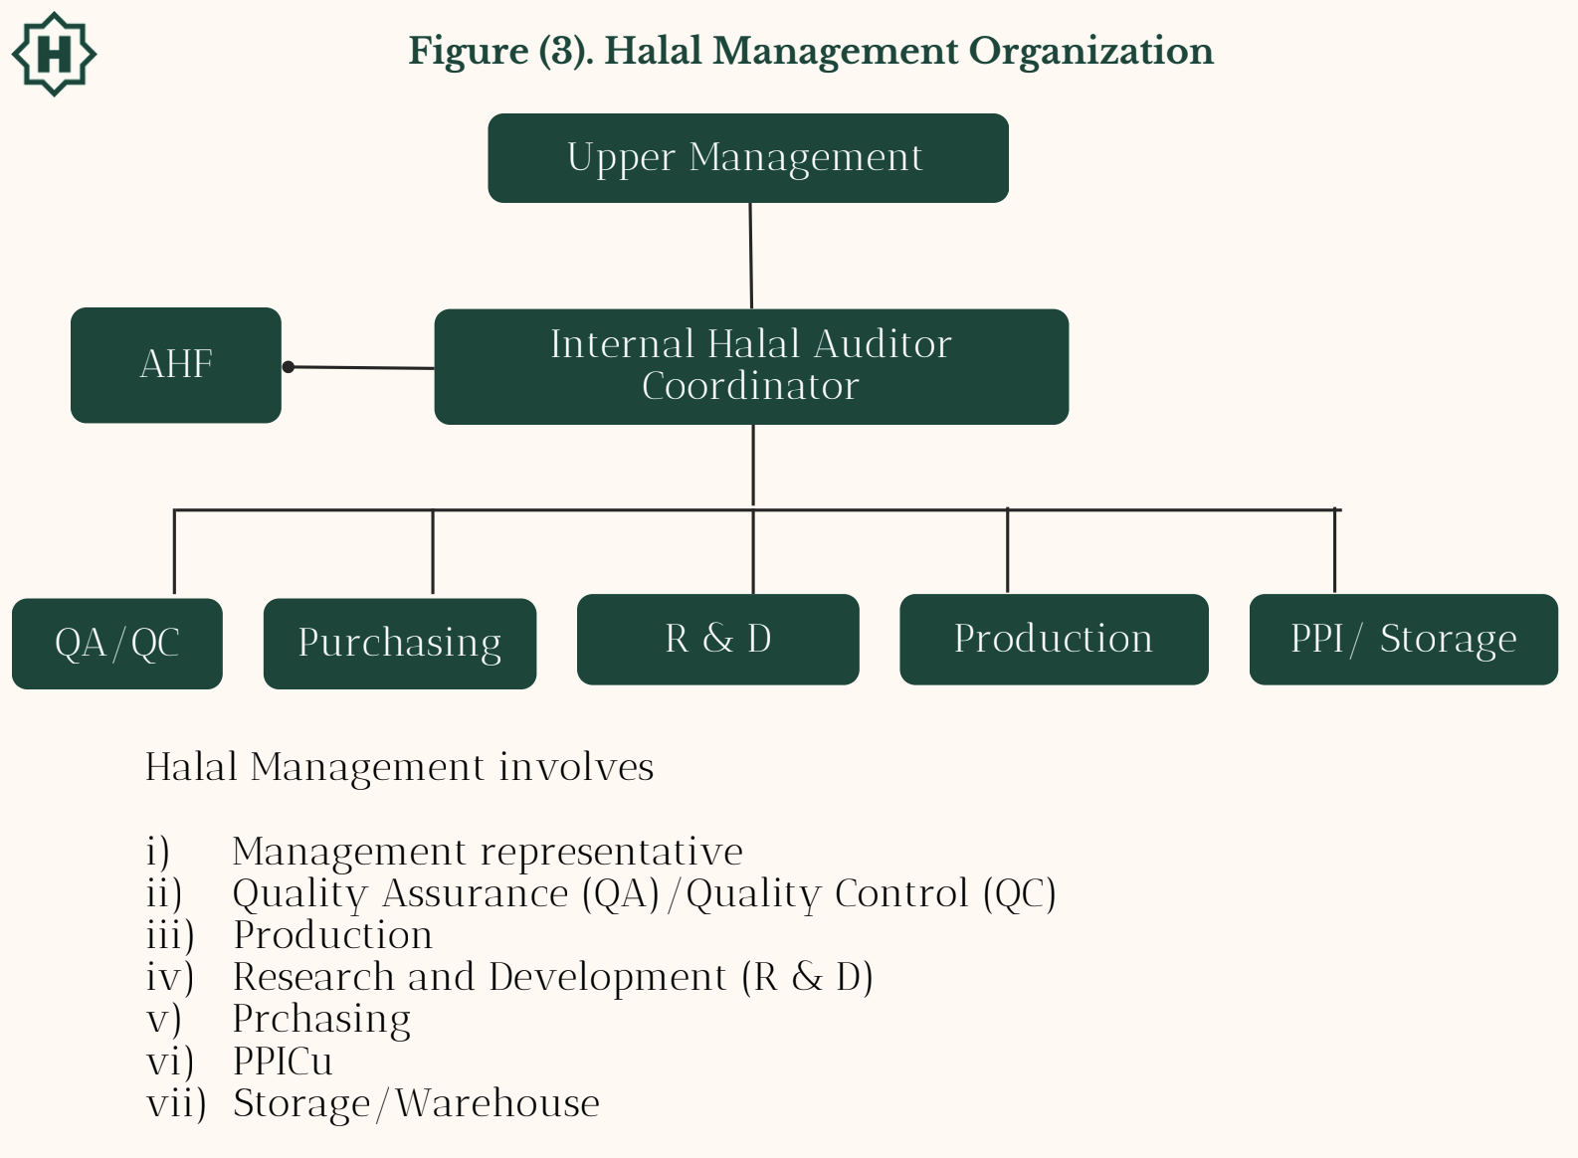

1. **Standard Operating Procedures (SOP)**

Standard Operating Procedures (SOP) is a set of standard instruction tools to complete a certain routine process. SOP is set up as standard procedure in HS implementation. SOP is established for all activities in halal production process i.e SOP for Purchasing, QA/QC, Production and Storage/Warehousing. Due to different complexity levels in a company, SOP(s) are unique. Example of AHF’s general guidelines of halal scheme system, 15 key activities in SOP for halal production are SOP for material purchasing, SOP for new material usage, and SOP for new supplier change, etc. Example of SOP(s) is attached in Appendix 9.

1. **Technical References**

HS implementation is done by all related departments in halal management organization. To guide its implementation, technical references are needed as supporting documents. The technical references are distributed to all departments.

Technical references for Purchasing Departments

1. List of approved materials consisting name of material, supplier, and producer approved by AHF.
2. Regulation of AHF related to the product (Certificate for every shipment, Halal Certificate period, specific halal logo on package, etc).
3. SOP of new supplier change.
4. Identification of Haram critical points of materials.
5. SOP for new material usage.
6. Product formulas.
7. SOP for halal production.
8. SOP for incoming materials checking.
9. Material/product storage procedure to avoid haram and najis contamination.
10. SOP for materials receiving and storage.
11. **Administration System**

Companies must set up an integrated, accountable, and traceable administration system. Administration system on HS is started from purchasing administration (Purchasing), material receiving (Quality Control/QC), material storage (Warehousing), Research and Development (R&D), Production/Operational, Product Storage (Finish Product) and Distribution. Examples of blank administration forms should be attached in the AHF system.

1. **Documentation System**

AHF implementation in companies must be supported by good documentation and accessible by every related part in halal production system, as per AHF as well. Documentations should be maintained are:

* 1. Material Purchasing documents
  2. Material Receiving documents
  3. Material Storage documents
  4. Research and Development (Formulation) documents
  5. Production (Production Process and Production Facility Cleaning) documents
  6. Product Storage documents
  7. Product Distribution documents
  8. Evaluation and Monitoring (periodical report) documents
  9. Training and Socialization activities documents
  10. Improvement’s action for non-conformities documents
  11. Management Review documents

AHF will explain the documentation of each function along with the responsible person in charge and divisions. Example of document system is attached in Appendix 11.

1. **Socialization Program**

HS must be socialized to company stakeholders including third parties (supplier, toll manufacturer). These activities are aimed at creating awareness of all stakeholders on halal policy, to encourage them to apply it at operational level. Halal policy socialization could be in the form of poster, leaflet, general lecture, internal bulletin, supplier audit or company internal memo.

1. **Training Program**

Company needs to conduct training for all staff and employees. Companies must identify the topic of training in a certain period. Training must involve all staff whose jobs may affect the halalness of the products.

The objectives of training are:

* 1. To improve employee’s knowledge on the importance of the halalness of product, critical points of materials and process.
  2. To make employees understand the Halal scheme.

Example of Training Schedule is available in AHF-F-036.

1. **Internal and External Communication System**

Internal and external communication is an important activity in HS implementation. For this reason, company must establish and implement procedure for:

* 1. Internal communication among all organization levels and functions.
  2. Receiving, documenting, and responding to communication from external sides including AHF.

1. **Internal Audit System**

Internal audit is needed to monitor and evaluate Halal scheme (HS) implementation by the company itself.  
a. Internal Audit Objectives

* + 1. Determining the conformity of HS according to the standard of AHF and the international standards.
    2. Determining the conformity of company HS implementation with planning.
    3. Detecting nonconformities occurred and to decide corrective and preventive actions.
    4. Ensure that the problems found in the previous audit have been corrected according to the time frame scheduled.
    5. Providing information about HS implementation to the management. Example of the form of periodic report is attached in Appendix 13.
  1. Internal Audit Scope

Scope of internal auditing covers examination of HS documentation and implementation.

1. Halal scheme System Documentation  
   HS documentation which needs to be examined are as follows:

list of materials, halal certificates, specifications, formulas, purchasing documents, storage documents etc. The items that need to be checked:

* + - 1. Completeness of Halal Assurance System document
      2. Completeness of Material Specification
      3. Completeness and validity of material halal certification
      4. Conformity between formula and list of halal material
      5. Conformity between material purchasing document and list of halal material
      6. Completeness and conformity between production document and list of halal material and formula
      7. Completeness and conformity between warehousing/ storage document list of halal material and product
      8. Traceability of system
    1. Halal scheme System Implementation

HS implementation audit covers:

* + - 1. Halal Management Organization
      2. Completeness of HS Implementation Technical Reference documents
      3. Document traceability
      4. HS Socialization
      5. Training
      6. Internal and External Communication
      7. Internal and External Communication
      8. Monitoring and Evaluation of HS Implementation
      9. Internal and External Report of HS Implementation
  1. Internal Audit Activity
     1. Schedule

Internal Halal Audit is conducted at least every year or at the time of any changes occurred that may affect halal status of product, such as changes of management, policy, formulation, material, and process.

* + 1. Method

Internal Halal Audit can be conducted by using these methods:

1. Interview and cross checking
2. Interview and cross checking

Example of Form for Internal Audit (Key Questions in Halal Internal Audit) is attached in Appendix 14.

* + 1. Auditor

Internal Halal Audit is conducted by AHF Team which is officially assigned by company management.

* + 1. Auditee

Auditee are all departments related to the process of halal production, i.e:

* + - 1. Purchasing Department
      2. QA/QC Department
      3. Production Department
      4. R & D Department
      5. Warehousing/Storage Department
      6. Transportation and distribution Department
      7. HRD Department
      8. Outlet (for restaurant)

1. Corrective Action System

Corrective action for HS implementation is taken if any non-conformities of implementation were found at a time of internal halal audit were conducted. The corrective action must be taken as early as possible, especially if it will cause a direct effect on product halal status. All forms of corrective action taken by the company are well-documented in a written record. Example of non-conformity report form is attached in Appendix 15.

1. Management Review System

A comprehensive management review of HS must be conducted in a certain period at least once a year. Management review must be done by all divisions involved in HS, including top management. Review meetings must be recorded. Example of minutes of meeting form is attached in Appendix 16.

1. **HS Implementation Assessment**

**7.1. Principles and Procedure of HS Assessment**

Principles of assessment for HS System and implementation are as follows:

1. Following all rules of AHF and international standards
2. Fulfilling all administration requirements
3. In accordance with HS principles
4. Appropriateness of scheme with the implementation
5. Ability of the system to assure the halalness

Procedure for assessment of HS consisted of several steps as follow:

1. Availability of documents (as required in halal certification process)
2. Assessment of HS System (On Desk Appraisal)
3. Field Auditing (Assessment of HS Implementation)
4. Evaluation and assessment in Auditor Meeting
5. HS implementation categorization

**7.2. Assessment of HS Scheme (On Desk Appraisal of HS)**

AHF provides a questionnaire for assessment of the HS system. The points of HS that will be checked consist of:

1. profile including company name, address, kind of products, production capacity, production line, toll manufacturing, market area, etc.
2. Statement of Company halal policy, objective and description of HAS implementation
3. Halal guidelines
4. Identification of haram critical control points and its preventive action of:
   1. Raw materials
   2. Production
   3. Distribution and display (for restaurant)
5. Halal management organization:
   * + - 1. Organization of AHF team
         2. Availability of assignment letter for AHF team
         3. Qualification of AHF coordinator
         4. Authority and responsibility of Team leader coordinator
         5. Authority and responsibility of representative of top management
         6. Authority and responsibility of R&D, Production, Warehousing, QA/QC, Purchasing, or other division related to halal management organization
6. Technical references for each division in halal management organization as guidelines in implementing of HS
7. Evaluation of SOPs content whether they have fulfilled halal criteria or have not.
8. Description of administration and documentation system (explanation of traceability system)
9. Planning of training and socialization of HS
10. Description of procedure for monitoring and evaluation of HAS (internal audit system)
11. Procedure of Management Review of HS
12. Availability, completeness, and adequacy of appendices

Assessment criteria for on desk appraisal are as follows:

1. Availability of documents

2. Adequacy of documents

3. Conformity with company condition

According to assessment criteria, AHF will assess the submitted HS. The results of HS assessment will be summarized and rechecked by management of AHF. The summary of on desk appraisal will be sent to the company as an audit memorandum. There are 2 recommendations of on desk appraisal result:

* 1. Need revision
  2. Passed (able to be HS implementation audited)

**7.3. Assessment of HS Implementation**

For companies which have passed on desk appraisal and have implemented HS at least 6 months, AHF will do an audit of HS implementation. This audit is aimed to verify how the system is implemented. The object of the audit is proof of system implementation from material purchasing system, material receiving, material storage, new product development, material removal/changes, vendor/supplier changes, internal and external communication, production planning, production process, final product storage to transportation.

Methods that are used on HS auditing are:

1. Interviewing all related staff/ workers
2. Collecting evidence (documents, records, etc related to production system)
3. Verifying and validating the system

The points that will be audited consist of:

1. HS implementation
2. Monitoring and evaluation of HS
3. Management review
4. **HS Implementation**

Assessment of HS implementation will be conducted by:

* 1. Evaluation and verification of halal management organization (fulfilled of the qualification, availability of assignment letter for AHF team)
  2. Evaluation on implementation of halal policy which consists of:
     + 1. Socialization, training, and dissemination of halal policy to staffs/workers
       2. proof(s) of statement in halal policy
       3. how integration of halal policy is part of the company's whole policy.
  3. Checking and examining availability and accessibility of technical references for each division in halal management organization:
  4. SOP(s)
  5. List of halal approved raw materials
  6. Identification of Haram Critical Control points of raw materials, production, distribution - display and its preventive action
  7. List of approved halal certifier body by AHF
  8. Regulation of Halal Certifying Body related to the product (Certificate for every shipment, Halal Certificate period, specific halal logo on package, etc.)
  9. Etc.
  10. Documents of HS implementation:
      + 1. record /written documents of all steps related to the production system including purchasing documents, warehousing/storage, material issue voucher, implementation of working instruction and SOP(s), etc.
        2. traceability.
        3. proof of involvement of team leader in production system (authorization of AHF team in halal production step).
        4. the position of HS documents among documents of other(s) quality systems and how they are implemented.
  11. Communication
      + 1. external communication between Team leader and client if there are any changes.
        2. internal: proof of internal meeting and its frequency, proof of internal communication between team leader and top management and its frequency.

1. **Monitoring and Evaluation of HS**

In this point, AHF will do verification of the system that has done by company (Internal Audit System) to assess the effectiveness of HS by checking the documents as follows:

* + - * 1. frequency of internal audit.
        2. procedure (auditor, auditee, audit technique, etc.)
        3. documents of audit results.
        4. internal audit report to the top management (findings, corrective action, due date of finalization).
        5. external report to AHF (documents, frequency).

1. **Management Review**

Assessment of management review point will be conducted by:

1. Verification of the system that brings attention to findings for preventive action and the system to detect, analyze, and eliminate potential causes of all kinds of non-conformities.
2. Checking the procedures of HS review due to non-conformity of HS implementation and/or change of management system that affect HS function.

The results of HS implementation assessment will be reported in the HS team meeting and management of AHF.

**7.4. Grant**

Output of HS implementation assessment will be given to the company by AHF as a Statement Letter of HS Category and HS Certificate. Statement Letter of HS Category will be issued after a HS implementation audit conducted but HS certificate will only be issued if the company has closed all non-conformities. Validity of HS Certificate is a 3 years cycle.

Rules of AHF certification process applied to the HS certificate holder are shown in the AHF FLOW CHART.

1. **HS Implementation Advantages**

Advantages of implementing Halal Scheme System are:

1. Company will have guidance in maintaining the sustainability of halal production process.
2. Assure the halalness of the product in a valid period of Halal Certificate.
3. Giving an assurance and spiritual tranquility for Muslim society.
4. Prevent any cases related to the non-conformity that damages the halal-nature of the product.
5. Protect from any unhalalness cases that may cause a company loss.
6. Increasing consumer loyalty to the halalness of products.
7. Creating an internal halal awareness in the company to keep the sustainability of halal production.
8. Appreciation from consumers (customer satisfaction) and external institutions (obtain and maintain halal certificate).

**Appendix 1. Example of Halal Policy**

PT is committed to consistently produce halal products in meeting consumers needs including those of the Muslim consumers. We will achieve this by:

* + 1. Ensuring all finished products made for the world market are certified halal by AHF.
    2. Ensuring all raw materials procured and used in the manufacture of our products are halal.
    3. Ensuring the production systems are clean and free from non-halal and filthy ingredients.

**Appendix 2.** **HALAL GUIDELINES**

1. **Preface**

In this part the principle of halal and haram in Al Qur’an and Fatwa from MUI will be described.

Sources of Islamic Law:

1. Al Qur’an. It is The Holy Book of Islam. It contains philosophy, principles, and theories of Islamic laws which are work of Allah for the guidance of mankind. It mainly prescribes permanent, absolute, values and basic principles of Islamic laws.
2. Al-Hadith. It is the authentic practice of Prophet Muhammad (the saying, actions, habits, and approvals) that explain in detail the application of the Qur’anic principles.
3. Ijma sahaaba. It is the consensus of the opinion of the sahaba (companions of the prophet Muhammad based on their understanding of The Al Qur’an and Al Hadiths).
4. Qiyas. It is a law-making method by comparing things with cases already explained in Al Qur’an and Al Hadiths.
5. Fatwa. It is Islamic legal opinion about the law status of a certain case made by Ulama (Islamic Scholars).
6. **Meaning Of Halal Haram**
   * 1. Halal means lawful. In the case of food, most are halal except for some that are explicitly mentioned in the Al Qur’an al Hadits.
     2. Haram is something prohibited by God Almighty. People who deliberately ignore what is not allowed will face God’s punishment in the life hereafter. Some even face Islamic law sanctions in life.

**C. Principles on Halal and Haram Status**

1. Everything is halal unless explicitly forbidden
2. Only Allah has the right to legislate for man
3. Prohibiting halal and permitting haram is unlawful
4. Haram is always associated with what is bad and harmful
5. There is always a better substitute in halal for the haram
6. Anything that leads to haram is considered haram
7. It is haram to declare something halal when it is manifestly haram
8. Good intentions do not justify committing haram
9. One should guard oneself against matters that are on the borderline between halal and haram
10. In extreme circumstances, haram is permissible within certain limits.

**D. Halal and Haram in Al Qur’an**

1. Al - Baqarah 168: “O ye people! Eat of what is on earth. Lawful and good; and do not follow the footsteps of the evil one for he is to you and avowed enemy.
2. Al Baqarah 172-173: “O ye who believe! Eat of the good things that we have provided for you and grateful to Allah, If it is Him ye worship. He hath only forbidden you dead meat, and blood, and flesh of swine, and that on which any other name hath been invoked besides that of Allah.
3. Al-An'am 145: “Say: I find not in the message received by me by inspiration any (meat) forbidden to be eaten by one who wishes to eat it, unless it be dead meat, or blood poured forth, or the flesh of swine ---for it is an abomination – or what is impious, (meat) on which a name has been invoked other than Allah. But (even so), if a person is forced by necessity, without willful disobedience. Or transgressing due limits---thy Lord is oft-forgiving, Most Merciful”.
4. AL-Maidah 3: “Forbidden to you (for food) are: dead meat, blood, the flesh of swine, and that on which hath been invoked the name of other than Allah. That which hath been killed by strangling, or by violent blow, or by a headlong fall, or by being gored to death, that which hath been (party) eaten by a wild animal, unless They are able to slaughter it (in due form); that which is sacrificed on stone(altars); (forbidden) also is the division (of meat) by raffling with arrows: that is impiety.
5. Al Maidah 90 – 91: “O ye who believe! Intoxicants and gambling, (dedication of) stones, and (divination by) arrows, are an abomination of Satan’s plan is (but) to excite enmity and hatred between you, with intoxicants and gambling, and hinder you from remembrance of Allah, and from prayer; will ye not then abstain? “.
6. Al Maidah 96: “Lawful to you is the pursuit of water-game and its use for food—for the benefit of yourselves and those who travel: but forbidden is the pursuit of land game ---as long as ye are in the sacred Precincts or in pilgrim garb. And fear Allah, to whom ye shall be gathered back”.
7. Al A’raf 157:” … he allows them lawful what is good (and pure) and prohibits them what is bad (and impure) ….”

**E. Fatwa (Islamic Legal Opinion) Of MUI for Materials and Production Process (No. 4/2003)**

1. **Khamr**

a. Anything that is intoxicating is considered as khamr (alcohol drink).

b. Drinks containing a minimum of 1 % ethanol is categorized as khamr

c. Drinks categorized as khamr is najis (filth)

d. Drinks those are produced through a fermentation process containing less than 1 % ethanol are not categorized as khamr but are haram for consumption.

1. **Ethanol**
2. Ethanol produced by non khamr industry is not najis (pure)
3. Using of pure ethanol which is produced by non khamr industry is:

1. Mubah (allowed), if it is not detected in the finished product.

2. Haram (prohibited) if it is detected in the finished product.

1. Use of ethanol produced by khamr industry in food production is haram
2. **By product of khamr industry**

a. Fusel oil as a by-product of khamr industry is haram and najis.

b. Fusel oil which is not a by-product of the khamr industry is halal and not najis.

c. Component that is physically separated from fusel oil as by product of khamr

industry is haram.

d. Component that is physically separated from fusel oil as by product of khamr

industry and then chemically reacted to be a new compound is halal.

d. Vinegar is halal.

e. Yeast separated from khamr and washed to remove taste, smell and color

of khamr is halal.

1. **Flavor Imitating Haram Product**

Flavor using the name and having the sensory profile of a haram product, like rhum flavor, pork flavor, etc. could not be halal certified although ingredients used are halal.

1. **Microbial Product**
2. Microbes which grow on and halal growth media are halal, and which grow on

haram growth media are haram.

1. Microbial consumer products which use haram and najis materials on its growth media in all production steps (refreshing scale, pilot plant scale and production stage) are haram.
2. Consumer products containing microbial products which grow on non halal media are haram
3. Consumer products containing microbial products must be traced back to the initial growth media of the microbes.
4. **Use of Sharing Facility**
5. Facility that has been used to produce products containing pork must be cleansed seven times by water and once of them by dust or its substitute that has similar cleaning power.
6. Facility must not be alternately used for producing pork and non-pork products.

**F. Several Examples of Critical Materials**

1. Meat of halal animals could become haram if the animal is slaughtered not according to the Islamic law. Critical points in the slaughtering process are as follows.

1. Slaughter men must be devoted Muslims who daily practice the Islamic rites.
2. Knife must be sharp.
3. In the post slaughtering process, animal should be completely dead before
4. the next process begins and blood should be completely drained.

Imported meat should be supported by following documents or conditions:

1. Halal certificate from a halal certification body approved by AHF.
2. Shipment and other supporting documents such as shipping documents, health documents, etc.
3. Halal Certificate should conform to other documents.
4. The documents should conform to physical conditions, such as packaging and label.
5. Document must have the correct lot number, plant number, date of slaughtering, etc.
   1. Animal Derivatives.

Animal Derivatives are halal if they are derived from halal animals slaughtered

according to the Islamic law, not derived from blood and not contaminated by

haram (unlawful) and najis (impure) materials. Following are examples of animal

derivatives or materials that could be derived from animal derivatives:

1. Fat
2. Protein
3. Gelatin
4. Collagen
5. Fatty Acid and its derivatives (E430 – E436)
6. Salts or esters of fatty acid (E470-E495)
7. Glycerol/glycerin (422)
8. Amino acid (examples : cysteine, phenylalanine, etc.)
9. Edible bone phosphate (E521)
10. Di/Tricalcium Phosphate
11. Blood plasma
12. Globulin concéntrate
13. Fibrinogen
14. Microbe growth media (example: blood agar)
15. Hormone (example : insulin)
16. Enzyme from pig/cow pancreas (amylase, lipase, pepsin, tripsin)
17. Taurine
18. Placenta
19. Milk products and their derivatives and their by products which are processed by enzyme (example: cheese, whey, lactose, caseine/caseinate)
20. Several vitamins (examples: A, B6, D, E)
21. Activated Carbon
22. Bristle
    1. Vegetable Products

Materials derived from vegetables are basically halal but if processed with additives and/or processing aids that are not halal, they become not halal. Therefore, it is necessary to know the production process, the additives and the processing aid used in the making of vegetable products. Following are examples of vegetable materials that might have critical points:

1. Wheat flour could be enriched by vitamins, among them B1, B2 and folate acid.
2. Oleoresin (Chili, spices, etc) may contain emulsifiers (examples: polysorbate/tween & monoleat glycerol that might be derived from animals)
3. Soybean lecithin could be produced by using phospholipase in the production process to improve its function.
4. Hydrolyzed Vegetable Protein (HVP) could be produced by using enzymes in the hydrolysis process.
   1. By products of Alcoholic Drink Industry and their Derivatives

By-products of the alcoholic drink industry and their derivatives are haram if they are only physically separated from the product but if they are chemically reacted to be a new compound, they become halal. Example of byproducts of alcoholic drink industry and their derivatives are:

1. Cognac oil (by product of cognact/brandy distillation)
2. Fusel oil (by product of distilled beverages and their derivatives, such as isoamyl, isobutyl and propyl alcohol, acetaldehyde, 2.3 butanadiol, acetone, diacetyl, etc.)
3. Brewer yeast (by-product of beer industry)
4. Tartaric acid (by product of wine industry)
   1. Microbial Product

Status of microbial product could be haram if it belongs to the following categories:

1. Status of microbial product could be haram if it belongs to the following categories:
2. Microbial products grow on media containing haram materials such as blood, peptone from haram source or produced by using enzymes from haram source.
3. Microbial products using enzymes of haram materials in their production process.
4. Microbial products using haram additives or processing aid in their production process, such as antifoams derived from lard, glycerol or other similar substances.
5. Microbial recombinant genes derived from haram materials. Examples are as follows:
6. α-amylase enzymes and proteases resulting from Saccharomyces cerevisiae recombinants with genes from animal tissues.
7. Insulin hormones resulting from E. coli recombinants and genes from pig pancreas tissues.
8. Human growth hormones resulting from E. coli recombinants.
   1. Other Derivatives

The following are examples of other additives those often-become critical points:

1. Aspartame (made of amino acid phenylalanine and aspartic acid)
2. Natural colorings
3. Flavors
4. Seasonings
5. Vitamin coatings
6. Emulsifiers and stabilizers
7. Antifoams
8. Etc.

* E-Nº Food Ingredients Mashbooh/Haram

E-106 Riboflavin 5-Sodium phosphate Mashbooh

E-120 Cochineal, Carmines (Animal) Haram

E-140 Chlorophylls, Chlorophyllins Haram

E-161b Lutein Haram

E-252 Potassium nitrate, Saltpetre Haram

E-304 Fatty acid esters of Ascorbic acid Mashbooh

E-322 Lecithin from animal fat Mashbooh

E-431 Polyoxyethylene Haram

* **Beverages:**

Intoxicating beverages or those containing alcohols, narcotic, calming, toxicant or harmful substances.

* **Plantation:**

Plants, their products and their toxicant, harmful or narcotic derivatives, unless toxicant or harmful substances are removed during preparation.

* **GMO / GMF:**

All Food / Products produced by genetic modification from a prohibited species or more than one species.

* **Additives / Preservatives:**

All toxicant, harmful or calming food additives, products and their products and derivatives or derived from nonHalal materials.

* **Mushroom**

All types of mushrooms and their byproducts and/or derivatives are halal except those that are poisonous, intoxicating or hazardous to health.

* **Enzymes:**

All enzymes derived from non-Halal sources.

* **Microorganisms:**

All microorganisms such as germs, fungi, toxicant and harmful yeast produced on non-Halal environments or using non-Halal ingredients.

**Appendix 3.**

**DECISION TREE FOR HARAM CRITICAL POINTS IDENTIFICATION**

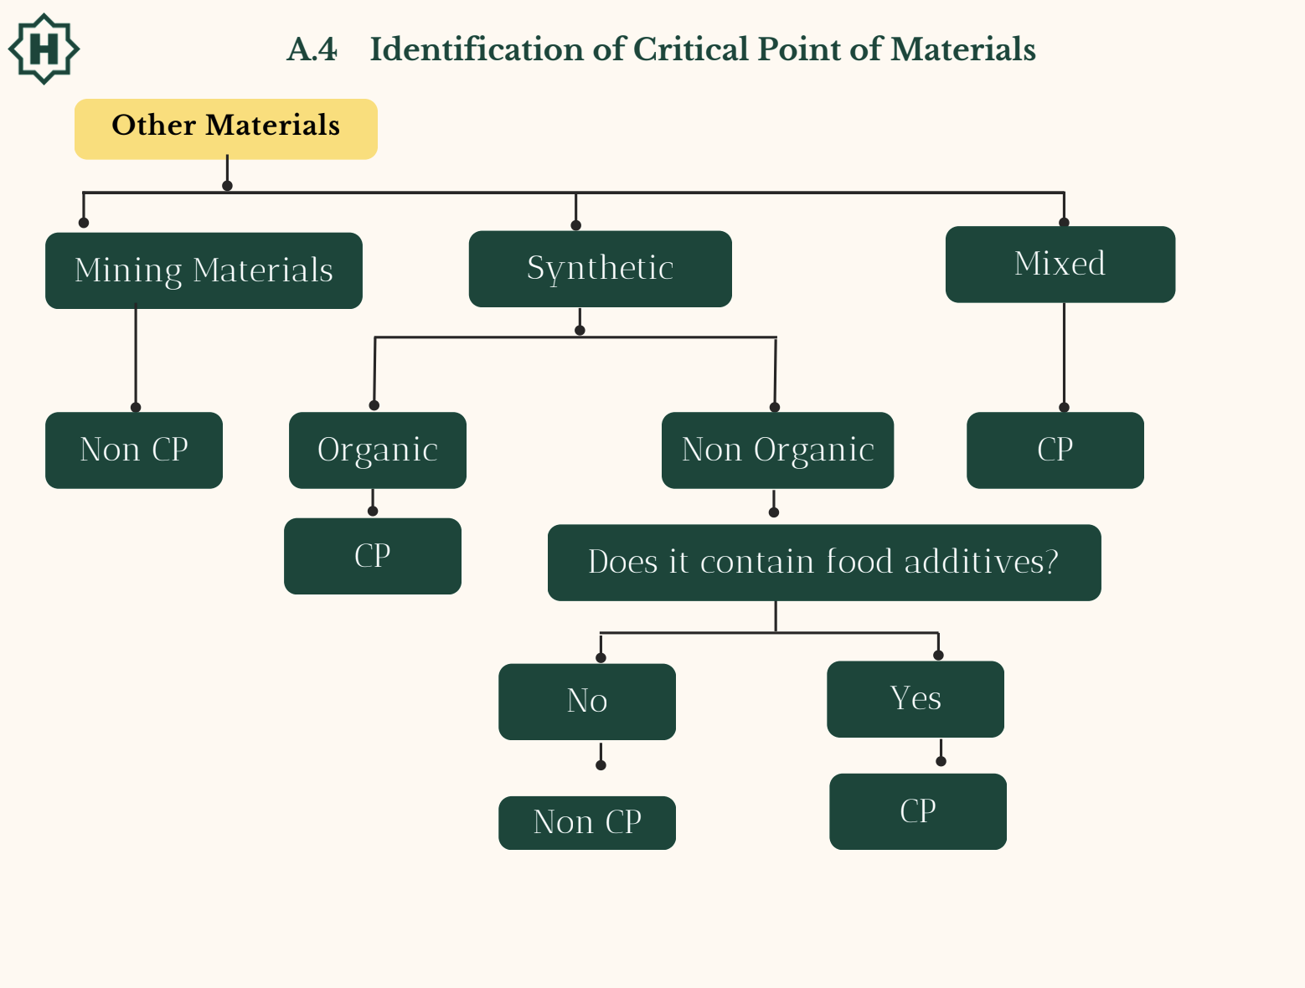

**Appendix 4.**

1. **Identification of Distribution Critical Points**

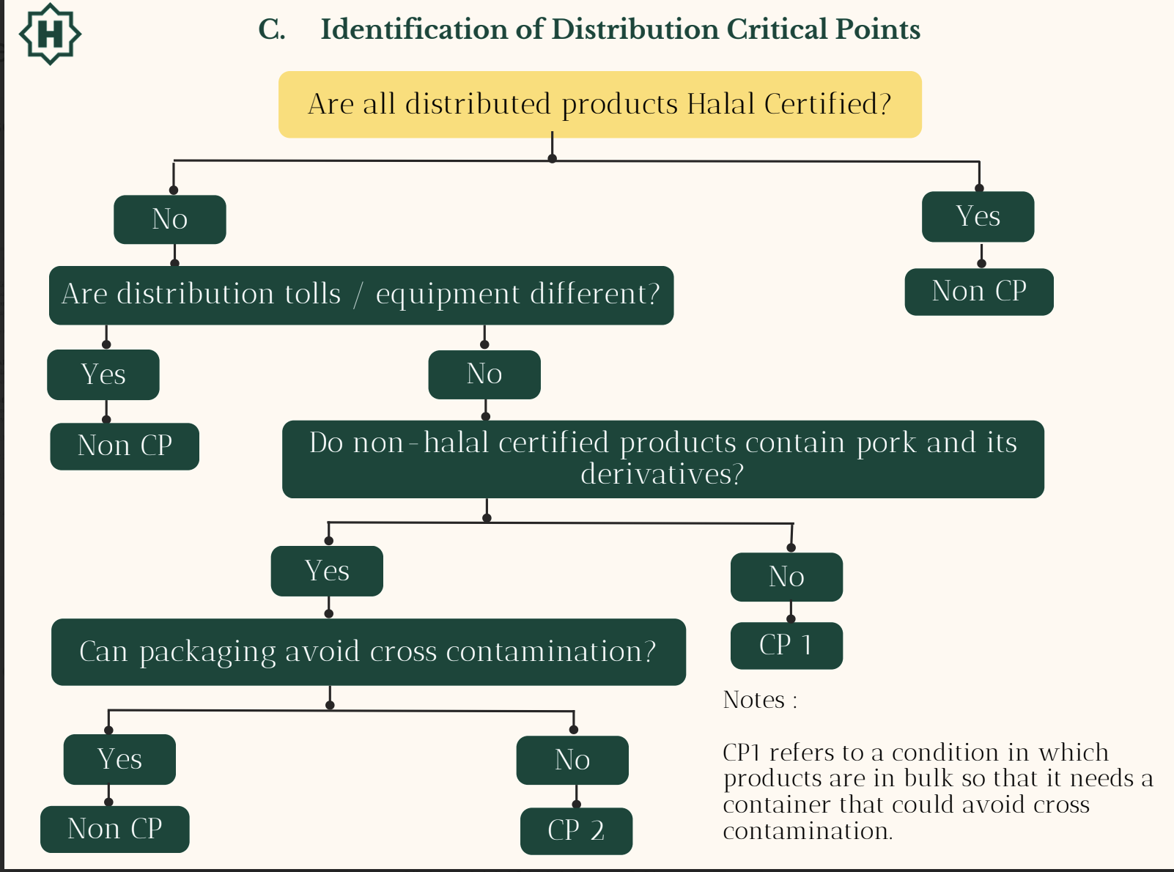

**Appendix 5.**

1. **Identification of Critical Points of Display**

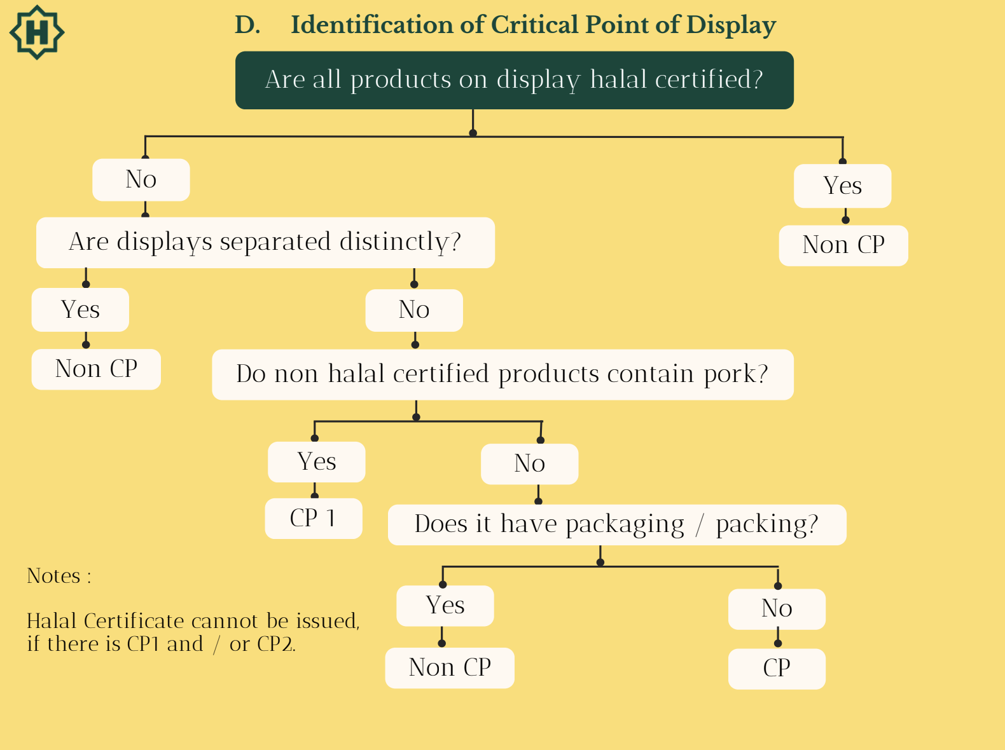

**Appendix 6.**

1. **Identification of Critical Points in Slaughtering**

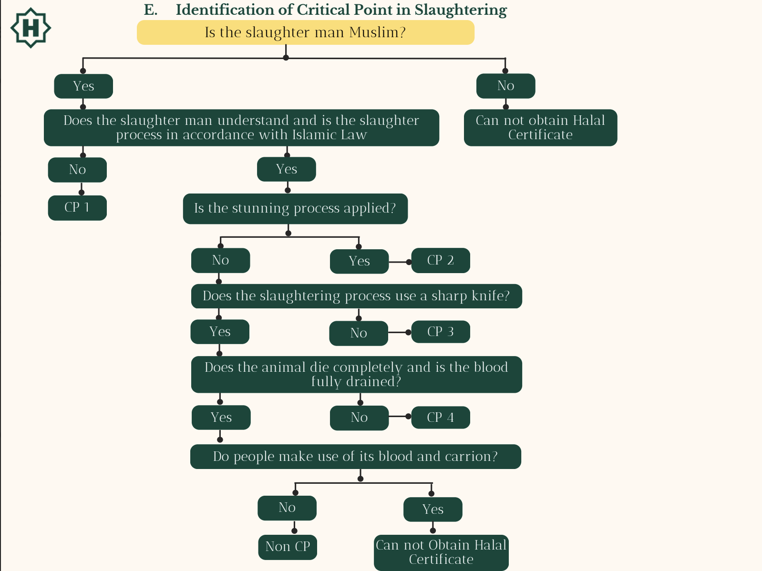

**Appendix 7.**

1. **Procedure of Determining Material Status**

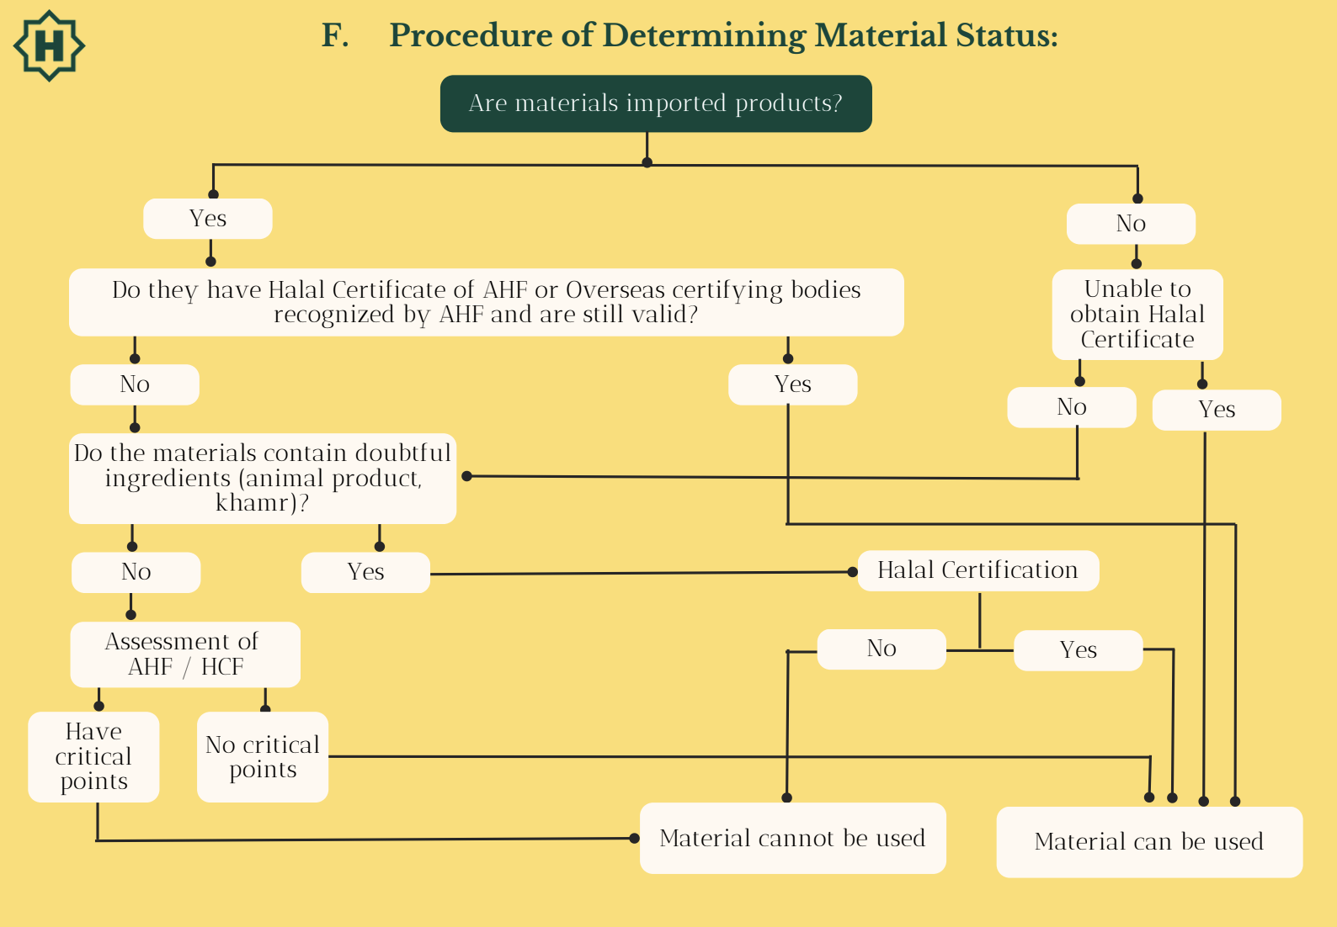

**Notes:**

**Notes :**

**1. This procedure applies to all producers and suppliers.**

**2. Output of above procedure is list of materials as reference for internal halal auditors.**

**3. Materials in the category of materials that can be used, must be approved by AHF /**

**before used.**

**4. Materials in the category of materials that cannot be used, must not be in the factory area.**

**5. Materials that can be used must have supporting documents like material specification**

**and / or halal certificate from AHF / HCF or overseas Halal Certifying bodies**

**approved by AHF.**

**6. Materials subjected to AHF assessment process must have approval letter from**

**AHF,**

**Appendix 8.**

**Example of List of Identified Haram Critical Materials and Its Preventive Actions**

| **Nº** | **Name of Material** | **Critical Point** | **Key Information** | **Corrective Action** |  | **Documentation** |
| --- | --- | --- | --- | --- | --- | --- |
| **1.** | **∙ Meat**  **∙ Gelatin** | **-Halal animals**  **- Slaughter** | **Halal certification** | **Reject materials if information in packaging does not correspond with halal certification.** | **Warning to supplier** | **-Corrective Action.**  **- Verification.** |
| **2.** | **Oleoresin** | **- Additives** | **Process flow** | **Reject materials if the information in packaging does not correspond with document** | **Warning to supplier** | **- Corrective Action.**  **- Verification.** |
| **3.** | **Isoamyl alcohol** | **-Khamr derivatives** | **Halal certification** | **Reject materials if information in the package does not correspond with halal certification.** | **Warning to supplier** | **- Corrective Action.**  **- Verification.** |
| **4.** | **MSG** | **Fermentation media** | **Halal certification** | **Reject materials if information in the package does not correspond with halal certification.** | **Warning to supplier** | **- Corrective Action.**  **- Verification.** |
| **5.** | **Antifoam** | **Raw materials** | **Halal certification** | **Reject materials if information in the package does not correspond with halal certification.** | **Warning to supplier** | **- Corrective Action.**  **- Verification.** |

**Appendix 9.**

**Example of List of Identified Haram Critical Production Process and Its Preventive Actions**

| **Nº** | **Name of Material** | **Critical Point** | **Key Information** | **Corrective Action** |  | **Documentation** |
| --- | --- | --- | --- | --- | --- | --- |
| **1.** | **Adding of raw materials** | **-Raw materials** | **Material must conform to matrix of materials approved** | **Stop using wrong materials; cleaning contaminated equipment; quarantine the product that a wrong material is added.** | **-Check production record.**  **-Check relevant SOP.** | **-Corrective Action.**  **- Verification.** |
| **2.** | **Equipment Selection of Mixing Tank** | **-Not using dedicated lines/tank** | **Must use dedicated tank for halal production** | **Stop production if using undedicated tank** | **-Check**  **relevant**  **SOP** | **- Corrective Action.**  **- Verification.** |
| **3.** | **Blending material** | **-Possibility of non halal material** | **Product ID, material List** | **-check a material pulling from warehouse**  **-ensure marking of halal products and supplier approved** | **Check**  **whether**  **conform to**  **halal**  **requirement** | **-Approved material list** |
| **4.** | **Cleaning equipment** | **-Residue of non-halal products** | **Halal certification** | **-Thoroughly clean the equipment** | **Check production record.**  **-Check relevant SOP.** | **- Corrective Action.**  **- Verification.** |

**Appendix 10.**

**Example of Halal Standard Operating Procedure (SOP)**

1. **SOP for Purchasing Department**
2. Material purchased should conform to the list of materials approved by the Accreditation center.
3. Companies must assure that materials purchased conform to data mentioned in the halal certificate halal document (name and code of raw material, name of company, name and location of factory).
4. Purchasing documents must be well documented.
5. **SOP for Receiving Materials**
6. Name of materials, code of materials, producer, name, and location of factory must conform to those contained in the list of raw materials approved by accreditation centers**.**
7. If halal certificate mentions a special logo, it must be shown in the packaging of the materials.
8. Materials with halal certificates issued per shipment should be accompanied with documents stating the lot number, quantity, production date and expiry date that conform to those mentioned in the halal document and mentioned in the label.
9. Materials that have been audited and conform to the criteria are given halal passes.
10. Materials stored in warehouses are materials that conform to the list of raw materials approved by Accreditation centers. If there are materials that are not mentioned in the list, they must be stored separately to prevent cross contamination.
11. Materials stored in warehouses should be free from contamination by anything that is Haram and Najis.
12. Each mutation of materials (going in and out) in the warehouse should be well recorded and must have stock cards, materials, issue vouchers and receiving documents.
13. **SOP for Changing and Adding New Suppliers**
14. If materials are of a critical category, it is recommended that a company has to check whether suppliers of the materials possess halal certificates issued by AHF or other recognized certifying bodies.
15. If a new supplier has no halal certificate, it is recommended to find another supplier processing halal certificate issued by AHF or other recognized certifying bodies.
16. If there are new suppliers with no halal certificates, then a technical specification examination explaining the source of origin and a production flow chart of materials must be provided.
17. There should be assurance that the materials purchased conform to data contained in the halal certificate or halal document (name and code of materials, name of company, name and location of the factory).
18. Companies should know whether a supplier is a direct producer or a distributor. In case the supplier is a distributor, a written agreement is to be made in which the supplier states that it only supplies materials that are contained in the halal document.
19. Planning for replacing suppliers should be reported to AHF before implemented.
20. Materials from new suppliers can be used after getting approval from AHF.
21. Data of active and inactive suppliers should be well documented.
22. **SOP for Use of New Materials**
23. New materials must be checked whether it has a halal certificate issued by AHF or other recognized certifying bodies.

**Date & Signature of Lead auditor:**

**Read and signed by company:**

**Date: 17th October, 2024**